Goethe-Institut Hongkong Discussion
on “Journey to Justice”

Date / Time: 23 Apr 2014 (Wed), 7pm
Venue: Agnès b. CINEMA!

Speakers:
-Dr. Martin Chung (Research Assistant Professor of EUAP)
-Dr. Gabriele Gauler (Director, Goethe-Institut Hongkong)

On 23 April 2014, Dr. Martin Chung of EUAP was invited by the Goethe-Institut Hongkong to the post-screening discussion of the documentary “Journey to Justice” by Steve Palackdharry. From Goethe.de: “Journey to Justice tells the story of Howard Triest, a German Jew who fled Nazi Germany in 1939 when he was 16 years old, returned as an American soldier and then served as an interpreter during the Nuremberg Trial. He came face-to-face with imprisoned Nazi leaders who were co-responsible for the death of six million Jews, including Howard’s parents at Auschwitz. At Nuremberg, Howard felt transformed, from victim to victor, and was able to reclaim parts of his German identity.” The discussion was led by Dr. Gabriele Gauler, Director of Goethe-Institut Hongkong, in which questions of collective guilt, cross-generational “co-liability”, remembrance and reconciliation were broached.
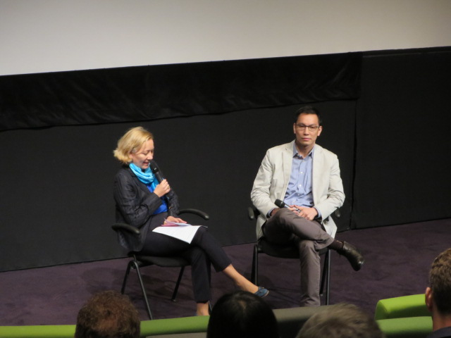
Dr. Gabriele Gaule and Dr. Martin Chung

Press Contact
European Union Academic Programme Hong Kong, Doris LEE (Assistant Programme Coordinator)
DLB 515, David C. Lam Building, Hong Kong Baptist University, Kowloon Tong, Kowloon, Hong Kong
Tel: (+852) 3411 6591 Fax: (+852) 3411 6588 E-mail: dorispylee@hkbu.edu.hk

