[FOR IMMEDIATE RELEASE]
30th October 2014
On 8th October 2014 the EUAP was honored to host Mr. Alexander Count Lambsdorff, Vice-President of the European Parliament, who joined the roundtable discussion ‘The New European Parliament and Commission 2014-2019: Foreign Policy Objectives and Challenges’.
Count Lambsdorff explained to the audience the responsibilities of the European Commission and the European Parliament regarding foreign policy. He described the EU neighborhood as crisis-prone and provided examples of backsliding democratic transitions in Egypt and Libya, as well as destabilizing actions of Russia in Ukraine. Moreover, among policy challenges he mentioned the accession negotiations with Western Balkans countries and Turkey. The discussants shared their opinions on Transatlantic Trade and Investment Partnership as the most important economic objective in external relations. Count Lambsdorff emphasized the unity between EU member states as a foundation for strong and effective Common Foreign and Security Policy. Accordingly, a European Union marked by divisions risks losing credibility and influence.

Dr. Auer pointed to the weaknesses of EU reliance on soft power and the concurrent lack of military capability. Count Lambsdorff agreed that soft and hard powers are inseparable. He acknowledged that the EU’s soft power has limitations and is not sufficient to face current security threats. In response to concerns of Prof. Cabestan over the prospects of making the EU more coherent, he mentioned the reduction of the number of EU Commissioners as one possible solution towards increased efficiency of policy making processes.
Debating the unstable situation in Eastern Europe, Dr. Auer stressed that the EU inadequately focused on stability of the region in the past and remains ill-prepared to respond to Russia. According to Count Lambsdorff, cooperation between the EU, which favors the status quo, and Russia as a revisionist power is highly difficult to achieve. The EU should not push forward with its involvement in countries entangled in unresolved territorial disputes such as Ukraine, Moldova or Georgia. Moreover, EU reliance on gas supplies give Russia strong bargaining power and encourages the EU to move towards closer cooperation in energy sector.
On the topic of the Islamic State, Count Lambsdorff argued that the problem should be addressed through military action and political cooperation with the Iraqi government. Moreover, various security institutions such as Europol and intelligence agencies have to strengthen their efforts to track, control and if necessary arrest Islamic extremists returning to Europe. Addressing recent discussions over revoking citizenship, he added that the right to come back to one’s country cannot be denied.
Dr.Chung guided the discussion toward the topic of EU diplomacy in the Asia-Pacific region and the importance of EU partnership with China. Count Lambsdorff stressed that the EU maintains close cooperation with Asian countries, however, focusing on the economy rather than security. Regarding relations between the EU and China, he stated that the EU may encourage China to reconsider its policies. However, the EU is unlikely to interfere in issues related to Chinese territorial integrity. He also commented on recent political events in Hong Kong, saying that the peaceful way of conducting demonstrations has gained a great degree of sympathy within the EU. Moreover, he argued that the demonstrators are not fighting to change the political system in China but to justly remind Beijing of the promise of democratization made previously and of the preservation of freedoms guaranteed by the Basic Law of Hong Kong.

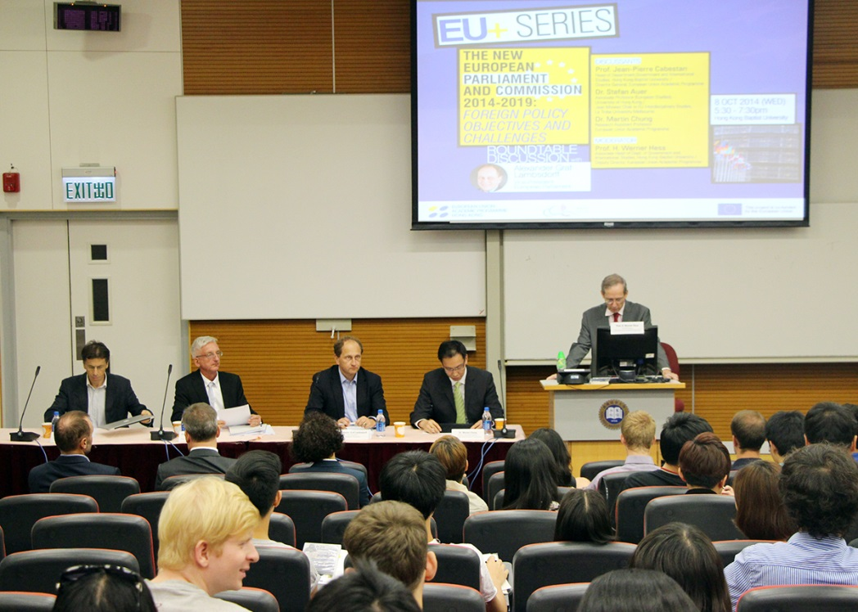
Prof. Jean-Pierre Cabestan kicking off the roundtable discussion with a brief introduction of the topic.

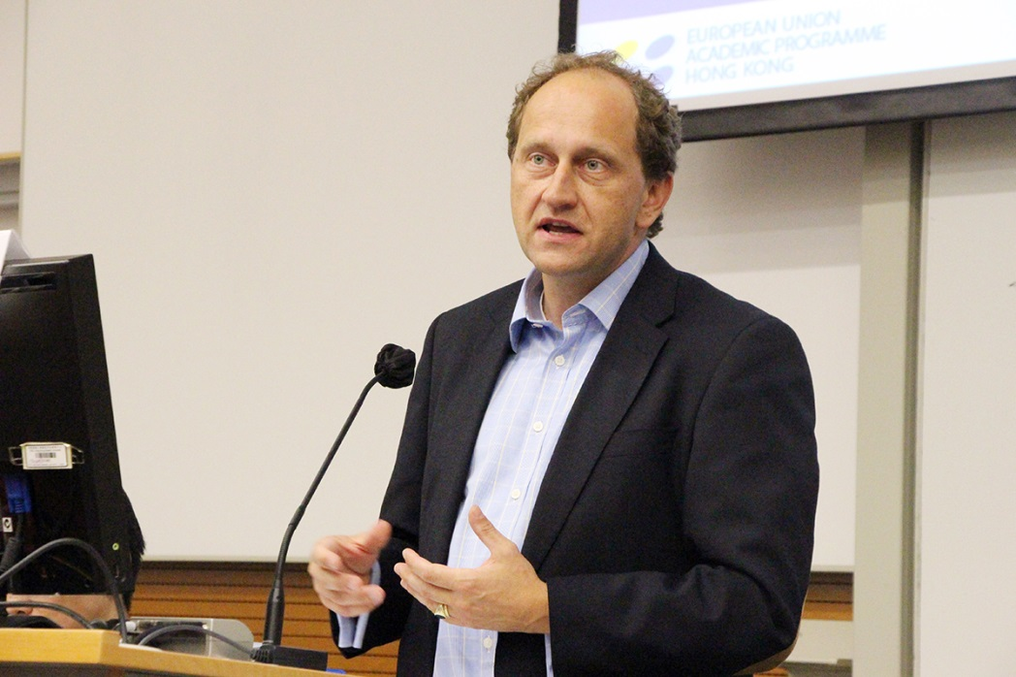
Mr. Alexander Count Lambsdorff, Vice-President of the European Parliament
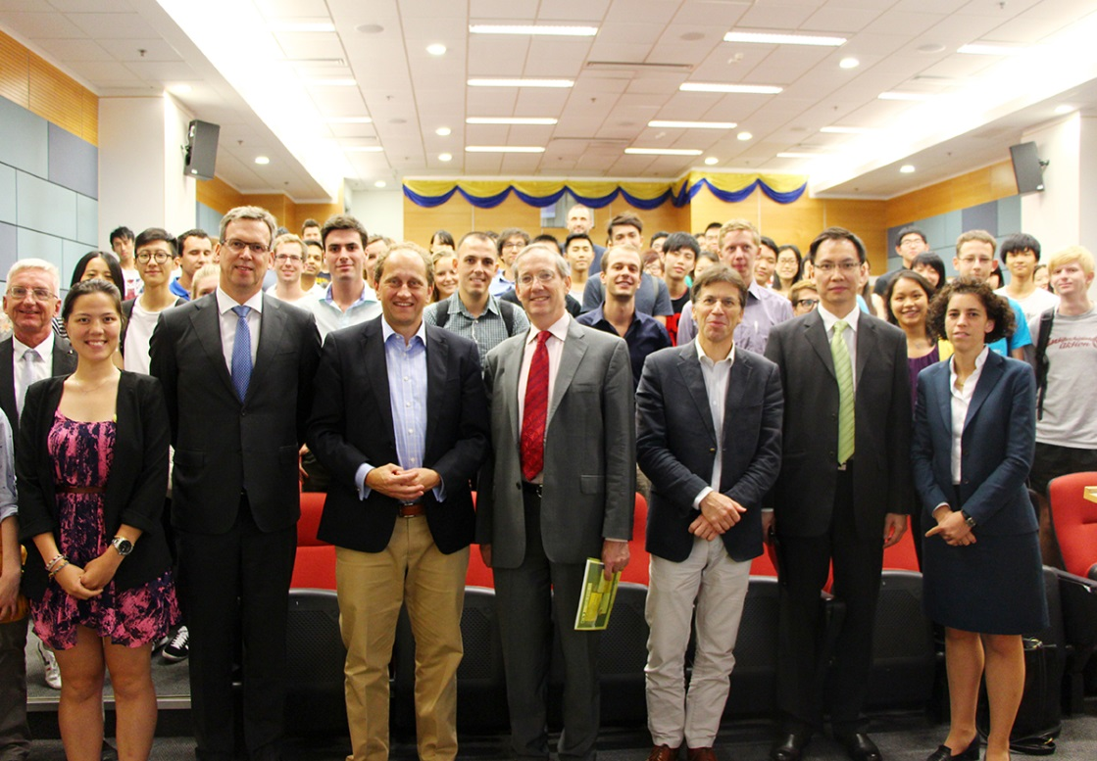
Discussants posing with participants after a heated discussion
Press Contact
European Union Academic Programme Hong Kong, Doris LEE (Assistant Programme Coordinator)
DLB 515, David C. Lam Building, Hong Kong Baptist University, Kowloon Tong, Kowloon, Hong Kong
Tel: (+852) 3411 6599 Fax: (+852) 3411 6588 E-mail: dorispylee@hkbu.edu.hk

